PIECES Framework Method To Measure The Effectiveness Of Obesity Explainer Animation Videos

***Abstract*—** **Along with the times, there are changes in people's lifestyles, especially in the capital city. The people of the capital city has new habit, likes consuming more fast food and reducing physical activity. If those happens continuously, people can become obesity which can cause dangerous diseases such as stroke, diabetes, coronary heart disease, hypertension and even death. Even the effect of obesity are dangerous, public awareness of obesity is also relatively lacking, this can be seen from the obesity rate in Indonesia which continues to increase from 10.5% in 2007 to 21.8% in 2018. To increase public awareness about how to handle obesity, it is needed providing information about obesity in the form of an explainer video that contains an explanation of obesity and also its handling with an attractive appearance. Through this explainer video about obesity, it can increase public understanding about obesity as much as 42.25. Respondents' level of satisfaction with explainer videos as an educational media regarding obesity treatment is 4,61 obtained from the test results using the PIECES Framework method. The author hopes that this explainer video can be an additional form of information about obesity.**

***Keywords—******explainer video, obesity, capital city, PIECES Framework***

# I. INTRODUCTION

The lifestyle in capital city makes it difficult for modern people to avoid fast food which contained high calories, fat and cholesterol. the wrong in choosing and minimum information of nutrition in food that consumed will causes health problems that may affect onutritional status. Good nutritional status can be achieved with a diet based on the principle of a nutritional menu with a variety of foods with appropriate portions [1]. the minimum of physical activity and a life that is accompanied by stress, especially in big cities, is starting to show an effect with the increasing problem of over nutrition, namely obesity.

|  |
| --- |
| XXX-X-XXXX-XXXX-X/XX/$XX.00 ©20XX IEEE |

Obesity is one of the risks of non-communicable diseases (NCD) such as coronary heart disease (CHD), stroke, and diabetes, which are the main causes of death in developed and developing countries. Obesity is characterized by excessive accumulation of body fat and is generally determined using the Body Mass Index (BMI), which is the ratio of body weight in kilograms to the square of height in meters [2].

Based on data from the World Health Organization (WHO), there are 1.9 billion adults who are overweight and 600 million of them are obese [3]. In Indonesia, the incidence of obesity in general increased from 10.5% in 2007 to 14.8%

in 2013 and continues to increase to 21.4% in 2018 [4]. The increasing prevalence of obesity and its serious impact on the population in various age groups in Indonesia are not only a

threat to individual health but also to the health condition of the Indonesian people at large, which can affect the country's economic condition [5].

Obesity is a global epidemic so it becomes a health problem that must be handled immediately. Referring to the health development goals or Sustainable Development Goals (SDGs), obesity treatment is one of the 3rd SDG’s targets, namely reducing one third of premature deaths caused by NCDs, as well as strengthening capacity in each country, especially in developing countries for early warning and risk reduction. concerning National and Global Health [6].

Based on this background, the author intends to propose the making of a Project with the title "PIECES Framework Method To Measure The Effectiveness Of Obesity Explainer Animation Videos". Graphic design evolved from static publishing unite with communication technology include film, interactive media, game and experimental design. By using the development of information and communication technology, the delivery of information is carried out by using the media in the form of animated explainer videos. The purpose of using animation media is to maximize the visual effect so that it increases understanding of the information conveyed and has the ability to explain something complex with pictures and words [7].

The application of the use of video explainers as an educational medium for handling obesity that has been implemented needs to be evaluated. There are many ways to evaluated a product. One of them is PIECES Framework which is a method that evaluates Performance, Information, economic, control, efficiency and service of a product [8].

# II. THEORETICAL BASIS

## A. Obesity

According to WHO, obesity is a condition where there is excessive fat accumulation due to an imbalance between energy intake and energy used for a long time. [9]. Based on data from the Ministry of Health of the Republic of Indonesia, the prevalence of obesity in Indonesia continues to increase. The obesity rate in adults > 18 years old showed a rate of 10.5% in 2007 to 14.8% in 2013 and is still increasing to 21.8 in 2018 [4].

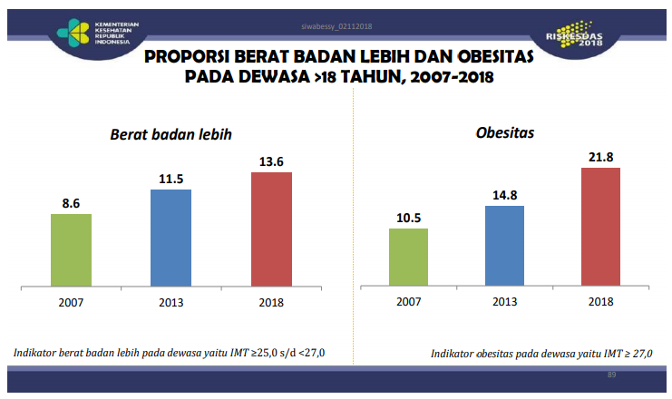

**Fig 1** Data on obesity rates in Indonesia

Clinically, a person can be categorized as obesity if they have a Body Mass Index > 27 kg/m2. For Asians, it is said to be obese if the BMI is > 25kg/m2. Identification of obesity can also be categorized through waist circumference measurement. If the waist circumference is > 90cm in men and > 80cm in women, it can be categorized as central obesity [10].

From the results of research conducted by experts, it shows that obesity can be influenced by several things, such as eating too much and minimum of physical activity. Obesity that is not treated immediately will cause several dangerous diseases such as stroke, type 2 diabetes mellitus, coronary heart disease, hypertension to death. Obesity is one of the risks of NCD which is the main cause of death in Indonesia [11].

Obesity can occur as a result of an unhealthy lifestyle that is carried out continuously for a long time, so that treatment will not be effective if done in a short time. According to the Ministry of Health, several things can be done to overcome obesity through the Healthy Living Community Movement, such as regulating diet, increasing physical activity and having regular health checks [12].

## B. Explainer Video

An explainer video is a short animated video that focuses on the purpose of explaining complex ideas/information into simpler, interesting and engaging information, using clear and concise language. Explainer videos are made with an attractive visual appearance with the aim of getting the attention of the audience [13]

## C. Typography for Motion Graphics

Typography is intended to make it easier for the audience to catch what is the topic of conversation so that they are more concentrated on it. The typography used in this motion graphics can be created according to the needs, and not excessive [14]. The following are the rules of the text displayed on motion graphics [15]:

1. Legibility: The ability of the reader to understand what is written.
2. Typeface: Unique style shape that forms a letter.
3. Points, Picas, Ems, and More: In this case, it is necessary to pay attention in choosing the weight of a letter. This is also related to the selection of the thickness of a letter, because it greatly affects the movement of the motion graphics itself.
4. It's Only Matter of Time: It is necessary to think about the amount of text used and its movement at one time, so that it can produce dynamic movements.
5. Kinetic Type and Movement: It is necessary to think about the movement techniques of a text so that the audience can enjoy the content of the video that is displayed.

## D. Composition on Explainer Video

Basically, a composition is a combination of several parts into a harmonious form [16]. Here are some principles of composition used in explainer videos:

1. Balance: the composition of the design can be said to be balanced if the objects on the left and right seem equal in weight.
2. Rhythm: a layout pattern created by arranging visual elements repeatedly.
3. Emphasis: the protrusion of one of the visual elements with the aim of attracting attention.
4. Size and Scale: the size of the visual elements need to be calculated appropriately in order to have a high value of ease in reading information.
5. Unity: merging design elements/elements by paying attention to balance, rhythm, comparison, and everything in a unified composition.

## E. PIECES Framework

Framework PIECES is a framework used to classify problems, opportunities, and directives contained in the scope definition section of product analysis and design. With this framework, new things can be generated that can be considered in developing products. In PIECES there are six variables used to analyze, including [8] :

1. Performance (Reliability): this analysis is carried out to determine the performance of a product, whether it runs well or not.
2. Information and Data (Data and Information); This analysis is used to find out how much and how clear the information users get from a product.
3. Economics (Economic Value): This analysis is conducted to determine whether a system is appropriate to be applied to an information institution in terms of costs incurred.
4. Control and Security, this analysis is used to determine the extent of supervision and control carried out so that the product runs well.
5. Efficiency (Efficiency): The efficiency and effectiveness of a system need to be questioned in terms of performance and the reason why the product was made. A system must be able to efficiently answer and help a problem.
6. Service: In terms of utilizing a product, a service is still an important thing and needs attention. A product that is applied will run well and in balance if it is balanced with good service as well.

# III. METHODOLOGY

The making of this project is divided into three stages, the first stage is the pre-production stage, then the production stage, after all the production processes are completed, the last process in making animation is the post-production stage.

## A. Research Data and Information

At this stage, the authors collect information about obesity. The collection of data and information was done by looking at books and journals related to obesity which were then validated online with a nutritionist named Adzra Izzati G, S. Gz.

## B. Study Existing

The existing study stage is carried out by collecting explainer video references regarding obesity that already exist, and analyzing each video. This stage is carried out with the aim that the author can compare the animated video that will be made with an existing video so that it can be used as a reference in the process of making an explainer video. The results of the analysis of existing studies that have been carried out can be seen in Table 1

**Table 1.** Study excisting result

|  |  |  |
| --- | --- | --- |
| **Video** | **Screenshot** | **Description** |
| How do We Lose or Gain Weight? By Neuron | https://lh6.googleusercontent.com/r4Kc8C87WQOX2EG9BUjZPxm6Awy8Vq-fEgC5A811ue7Kgjphy7V1QRo69I3EkF_NxhLKH4PNxJmduN0Pw-DAK5osvtqwF1Rl5Tf7exIa2v0vxAIwpzbXibLMfWzuK5FD3MQnhy3L | * This animation applies a flat design style to each of its assets * Use solid color for each asset * Use “sans serif” typography * Voice over filled with male dubber * Animated videos of 03.40 duration |
| Infographic Video Impact of Obesity for Teenagers By Salatiga City Health Office | https://lh5.googleusercontent.com/bPCGl06lAswTP4q6sNm8Uv37TxFFZeNVNcd7-rREg9odwCzPbdSO_hCjKshtHo8yKFptHORLP60n3cdpINwWg1w_H1U_dGtSs36QuMbBISXlLTTfnWCvOZ_lIlIrkkjvKfyMxUoi | * This animation applies a flat design style to each of its assets * Use solid color for each asset * Use “sans serif” typography * Voice over filled with male dubber * Animated videos of 04.40 duration |
| Infographic Video Public Service Advertisement about Obesity in Indonesia by Papoi AO | https://lh6.googleusercontent.com/FXJnDXztPcUVDz_d-JrvM9C7WXeFZ0RNuFz7z_-E6gbfQuJRQRvw2Gx_AZ8TLUDKZNG85cdO1vYU341BXE_-Ki0oWK7v9CLeNNkVb9URNkkw7X9Z-jbBFTP3gtPlE8vLIGkhUBHf | * This animation applies a flat design style to each of its assets * Use solid color for each asset * Use “sans serif” typography * Voice over filled with female dubber * Animated videos of 03.40 duration |

## C. Making Storyline and Storyboard

The storyline regarding the handling of obesity which explained sequentially starting from the delivery of the understanding, impact, characteristics and how to handling of obesity and ending with an invitation to implement the Healthy Living Community Movement program every day for a healthier Indonesia. Below is a list snipped from storyline table.

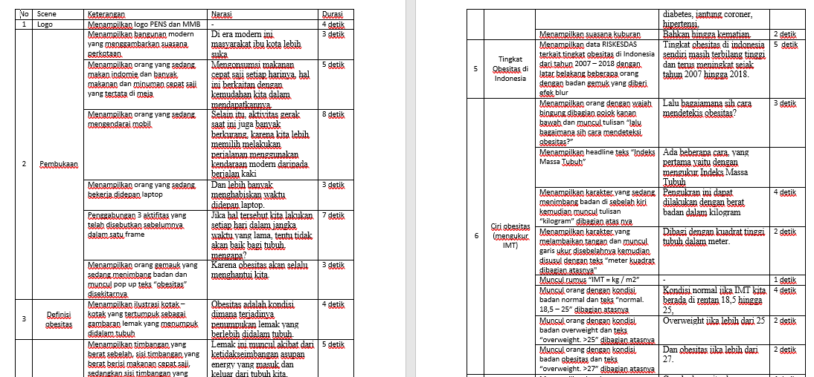

**Fig 2** Storyline

After that step, the storyline that has been made is developed into a voice over script.

## D. Expert Validation

Expert validation was carried out to ensure that the material and storyline for this obesity explainer video were appropriate. This stage is carried out by conducting interviews with experts in their fields, namely nutritionists. At this stage, the expert provides advice on the material provided, along with references that should be used. The author conducted online validation with a nutritionist, Mrs. Adzra Izzati G, S. Gz.

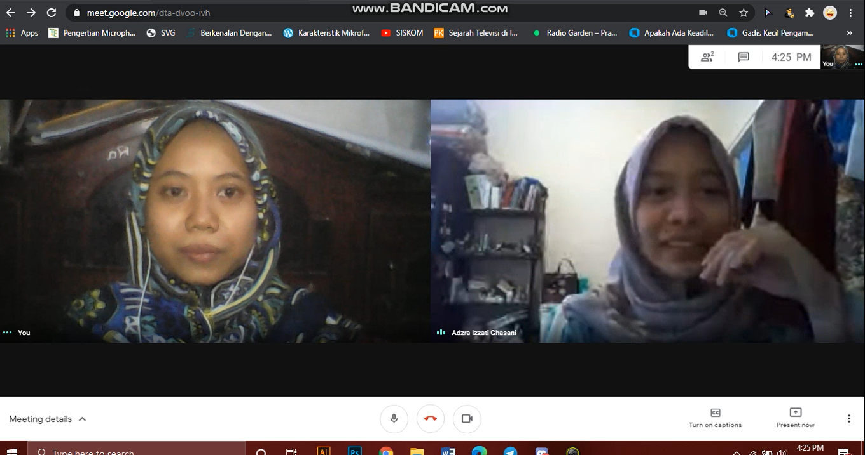

**Fig 3** Expert validation with nutritionists via google meeting platform

## E. Making Storyboard

Making storyboards is to make it easier for writers at the production stage, because on the storyboard there is a picture of each frame that will be displayed on the explainer video. Making storyboards is to make it easier for writers at the production stage, because on the storyboard there is a picture of each frame that will be displayed on the explainer video. Below is the storyboard.

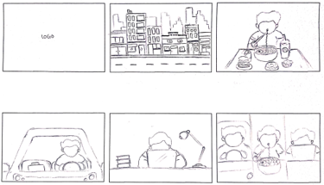

**Fig 4** Storyboard

## F. Video Content Visual Research

Visual research on video content was carried out by taking online questionnaires using Google forms. This visual questionnaire contains several choices of design styles from characters, assets, color palette choices and the type of font chosen by the respondents. The results of this research will later be used as guidelines for creating visuals from explainer video content. Below is results from visual content research.

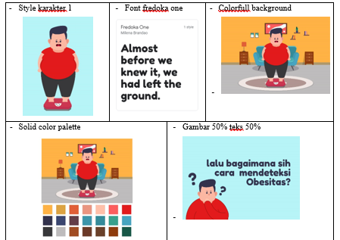

**Fig 5** Content visual research result

## G. Digitalization Of Characters and Assets

This digitization is made by adjusted to the storyboard that has been made before, using Adobe After Effects CC 2017 software. This asset and character creation is done by arranging each asset in several layers to make the animation process easier. Below is the process Of digitalization character and asset.

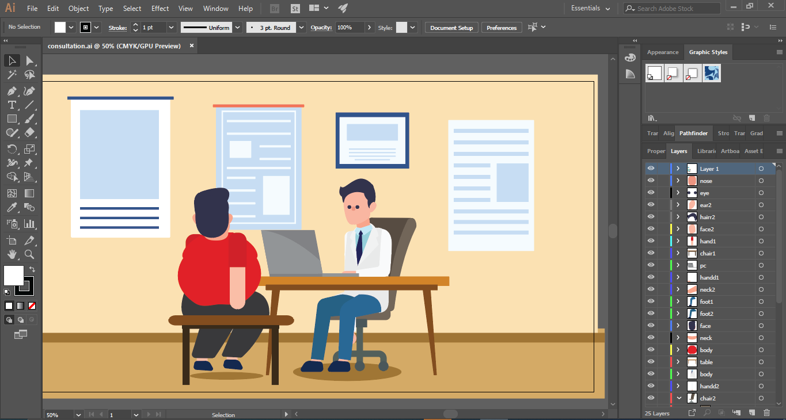

**Fig 6** Digitalization asset result

## H. Animation Process

Animation is a process where the assets that have been digitized will be animated using supporting software, namely Adobe After Effects CC 2017.

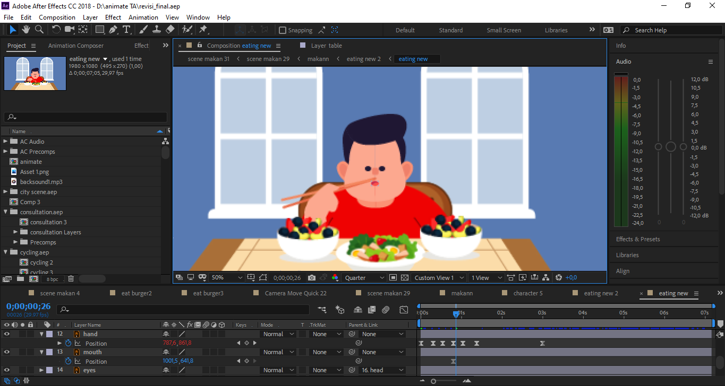

**Fig 7** Animating using Adobe After Effect CC 2017

## I. Recording and Editing Audio Voice Over

Voice over recording is done according to the script that has been made before. And then the recording results are edited using Audacity to remove noise and adjust the tempo.

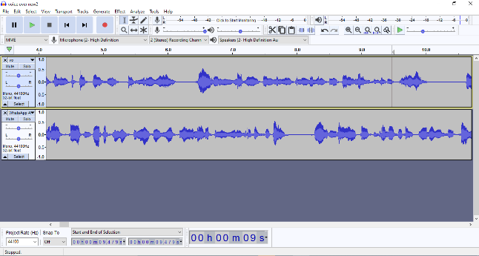

**Fig 8** Audio edting in audacity

## J. Editing and Rendering

At this step, the animation of each scene that has been created is combined. same with the animation process, this process also used Adobe After Effects CC 2017 for merging each scene and adding voice over and backsound.

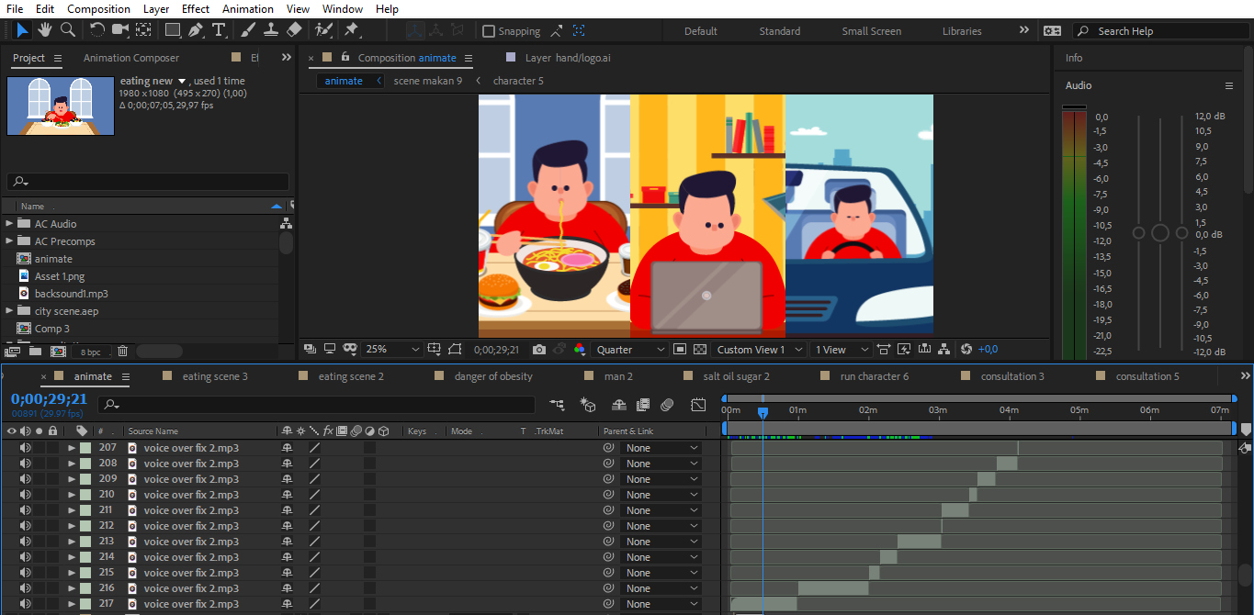

**Fig 9** Adding voice over using Adobe After Effect CC 2017

After all components have been successfully merged and adjusted, the last step is rendering. in this rendering process using Adobe Media Encoder to simplify the rendering process and so that the rendering does not have a large file size.

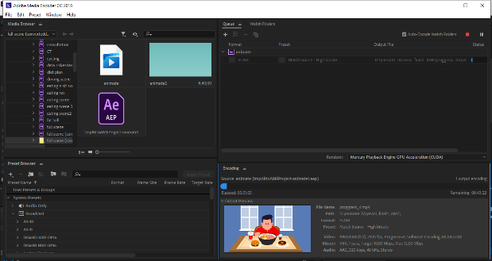

**Fig 10** Rendering use adobe media encoder CC 2017

## K. Testing and analysis

At this step, review are needed by nutritionist, animation experts and respondents. Testing to respondents is carried out through pre-test and post-test to determine whether the video made is in accordance with the objectives and expected benefits.

# IV. RESULT

In this section, the results of the trial and analysis from explainer videos to educate how to handling the obesity will be explained. The testing and analysis process was carried out by testing the animation results to nutisionist, motion designer and distributing two kinds of research questionnaires to respondents, which consisted of public knowledge about Stunting Prevention and one kind of animated video visualization assessment questionnaire.

## Testing on respondents

Through the pre-test and post-test questionnaires that have been made, it will be known the success rate of educational videos regarding the handling of obesity that have been distributed. This questionnaire was obtained from 49 respondents aged 15-25 years. The results of this questionnaire can be seen in the table below :

**Tabel 4. 1** Testing on respondents result

| **No** | **Pengetahuan** | **Success rate** | |
| --- | --- | --- | --- |
| **Pre-Test** | **Post-Test** |
| 1 | Definition/definition of obesity | **16,3%** | **89,8%** |
| 2 | Causes of obesity | **85,7%** | **100%** |
| 3 | Diseases that can be caused by obesity | **57,65%** | **82,7%** |
| 4 | Characteristics of obesity (BMI calculation) | **28,6%** | **87,8%** |
| 5 | Characteristics of obesity (central fat measure) | **36,7%** | **87,8%** |
| 6 | How to treat obesity  (Number of calories to be reduced) | **34,7%** | **81,6%** |
| 7 | How to treat obesity  (duration of physical activity) | **10,2%** | **57,1%** |

Based on the data presented above, it can be concluded that the total increase in respondents' knowledge about obesity from 38.55% obtained from the pre-test results has increased by 45.25% to 83.8% from the post-test results.

In addition to testing of the respondent's knowledge about obesity, satisfaction testing is also needed to see user satisfaction and impressions of the videos that have been made. This test is done by sending a questionnaire to the respondents. The questionnaires that have been distributed have succeeded in reaching 40 respondents with the following details:

1. 23 respondents who took the test were female and 17 were male
2. Of the 40 respondents, consisting of several age groups including 4 respondents aged 15 to 18 years, 4 respondents aged 19 to 20 years, 31 respondents aged 21 to 25 years and 1 respondent aged more than 25 years.
3. In addition to the difference in age, the respondents who took this test also had different activities, 4 respondents were in the student group, 27 respondents were students and 9 respondents were workers.

In this test, the researcher gave several questions to the respondents to find out the response of each respondent to the explainer video that had been made. The questions distributed to respondents are structured according to the PIECES Framework. Each question posed will be classified using the Likert scale method which has five value categories, namely 1 for Strongly Disagree, 2 for Disagree, 3 Moderately Agree, 4 Agree and 5 Strongly Agree.

Then, the results of respondents' satisfaction with the explainer videos that have been made will be processed using the formula that used to get the average value of the satisfaction rating:

Information:

RK = Rata-rata Kuesioner

JSK = Jumlah Skor Kuesioner

JK = Jumlah Kuesioner

In determining the level of satisfaction, researchers used one of the methods defined by Kaplan and Norton in table 4.2.

**Tabel 4. 2** Questionnaire Score Range

|  |  |  |
| --- | --- | --- |
| No | Value Range | Conclusion |
| 1 | 4.92 – 5 | Very satisfied |
| 2 | 3.4 – 4.91 | Satisfied |
| 3 | 2.6 – 3.39 | Quite satisfied |
| 4 | 1.8 – 2.59 | Not satisfied |
| 5 | 1 – 1.79 | Very Dissatisfied |

With the provisions in measuring the level of satisfaction as described in Table 4.2. Then the value to be obtained will be presented in Table 4.3.

**Tabel 4. 3** Rrespondents response

| Indikator | Respon | SA | A | MA | D | SD |
| --- | --- | --- | --- | --- | --- | --- |
| Skor | 5 | 4 | 3 | 2 | 1 |
| *Performance* | Q1 | 29 | 11 |  |  |  |
| Q2 | 24 | 15 |  | 1 |  |
| Q3 | 20 | 18 | 2 |  |  |
| Q4 | 20 | 19 | 1 |  |  |
| Q5 | 25 | 13 | 2 |  |  |
| Q6 | 24 | 14 | 2 |  |  |
| Q7 | 21 | 19 |  |  |  |
| Q8 | 20 | 19 | 1 |  |  |
| *Information* | Q9 | 17 | 17 | 6 |  |  |
| Q10 | 25 | 15 |  |  |  |
| Q11 | 24 | 15 | 1 |  |  |
| Q12 | 20 | 20 |  |  |  |
| *Economic* | Q13 | 22 | 17 | 1 |  |  |
| Q14 | 19 | 18 | 3 |  |  |
| *Control* | Q15 | 20 | 17 | 3 |  |  |
| Q16 | 20 | 19 | 1 |  |  |
| *Efficiency* | Q17 | 14 | 23 | 2 | 1 |  |
| *Service* | Q18 | 22 | 18 |  |  |  |

Questionnaire Results

Based on the satisfaction calculation value above, the level of user satisfaction with the Video Explainer To Educate Obesity Handling is included in the category “Satisfied”.

## B. Expert Review

Expert reviews were carried out to find out the assessment of people who are experts in their field of video explainer to Educate how to handling the obesity. The resource person who reviewed this project was Adzra Izzati, a nutritionist as a material expert. Arief Bahari as media expert.

1. Nutritionist

Testing with expert materials was carried out by Adra Izzati as a nutritionist through an assessment provided through Google Form. Here are the results of the test by the nutritionist:

**Tabel 4. 4** Expert material review result

| **Rating result** | **Question Points** |
| --- | --- |
| **Very good** | The truth of the content of the material about the causes of obesity |
| Clarity of the contents of the material described |
| Animation suitability with material |
| The suitability of the voice of the narration with the material |
| **Good** | The suitability of the content of the material about the description of obesity |
| Visual suitability (asset design) with material |
| **Enough** | The suitabilityof the content of the material about how to handle obesity |

1. *Motion Designer*

Mr. Yuwanda is a motion designer who has been in the animation world for more than 4 years. He has worked on many animation projects. Currently, Mr. Yuwanda is part of the marketing division of one of the marketplaces in Indonesia, namely Shopee, specifically in the Brand Creative section, as an animator. Based on this background, it is necessary to have a review from him, especially regarding visualization and audio which is implemented through this explainer video.

The assessment is carried out using the Google Form, and here are the results of a review by an animation expert:

**Tabel 4. 5** Expert animate review result

| **Rating result** | **Question Point** |
| --- | --- |
| **Very Good** | The accuracy of selecting the font type |
| Animation makes it easy to deliver material |
| Multimedia objects (text, images, photos, sounds, animations) complement each other's explanations |
| Backsound selection accuracy |
| Intonation in narrative |
| **Good** | Accurate selection of design styles for each asset and character |
| Color contrast with the background |
| Layout crash |
| Animation motion quality |
| *Animation rigging quality* |
| Consistent presentation of material in animation |
| Multimedia objects (text, images, photos, sounds, animations) are interesting |
| Narrative clarity |
| Accuracy of speed setting in narration |
| Easy to understand narration |
| No noise in the narration |
| **Enough** | Accuracy of color combination selection |
| Quality of the walking cycle |
| **Poorly** | Layout accuracy |

# V. CONCLUSION

Making and designing animations in the form of explainer videos to educate the handling of obesity is done by collecting data and information, excisting studies, making stories and scripts using the Approach, Intro, How it Works, and Call it to Action stages, material validation by nutritionists, making storyboarding, surveying visual content, digitizing characters and assets, animating each asset, recording voice over, editing and rendering. Furthermore, the explainer videos that have been produced are then tested on the respondents, nutritionists and animation experts.

Overall, the average value of respondents' knowledge about obesity during the pre-test was 38.55. Successfully increased by 42.25 to 83.8, this shows that this explainer video about handling obesity has educated the public regarding the definition, causes, characteristics, impacts and how to treat obesity. In addition, this explainer video about handling obesity also makes it easier for the public to understand the information contained in it.

The video succeeded in conveying information about obesity with an interesting story so that it was easy for viewers to understand and received a "satisfied" predicate from the respondents.

In terms of material in explainer video, the information submitted is considered good and appropriate because it is based on national data and recommendations. The visuals of the explainer videos also manage to get the message across well. Meanwhile, from a media expert point of view, this explainer video deserves to be published with a note that several revisions have been provided including, the quality of the audio recording, the articulation of the narrator, the addition of subtitles and the division of the video into several chapters which are separated by bumpers in each chapter.

REFERENCES

1. Kristianti, N. 2009. *Hubungan Pengetahuan Gizi dan Frekuensi Konsumsi Fast Food dengan Status Gizi Siswa SMA Negeri 4 Surakarta*. Skripsi. Universitas Muhammadiyah Surakarta
2. Misnadiarly. 2007. *Obesitas Sebagai Faktor Resiko Beberapa Penyakit.* Jakarta.Pustaka Obor Populer.
3. WHO. 2013. Global brief on hypertension: *Silent Killer, Global Public Health Crisis.* World Health Organization. Geneva
4. Kementrian Kesehatan Republik Indonesia. 2018. Hasil Riset Kesehatan Dasar (Riskesdas).
5. Gibney, M. J., Barrie M. Margetts., John M. Kearney, & Lenore Arab. 2008. *Gizi Kesehatan Masyarakat.* Alih bahasa Andry Hartono. Jakarta: EGC.
6. Hoelman, M.B., Parhusip, B.T.P., Eko, S., Bahagijo, S., Santono, H. 2016. *Sustainable Development Goals-SDGs*. International NGO Forum on Indonesian Development (INFID). Jakarta Selatan.
7. Calderon, N. A., Arias-Hernandez, R., & Fisher, B. 2014. *Studying Animation for Real-Time Visual Analytics: A Design Study of Social Media Analytics in Emergency Management.* Proceedings of the Annual Hawaii International Conference on System Scienced, 1, 1364-1371.
8. Soewadji, Jusuf. 2012. Pengantar Metodologi Penelitian. Mitra WacanaMedia. Jakarta.
9. World Health Organization. 2000. *Redifining Obesity and Its Treatment*.
10. Permenkes RI No.41 Tahun 2014 tentang Pedoman Gizi Seimbang
11. Rahajeng, Ekowati. 2012. *Upaya Pengendalian PTM di Indonesia.* Buletin Jendela Data dan Informasi Kesehatan
12. Kementrian Kesehatan Republik Indonesia, *Warta Kesmas*, Edisi 01,2017.
13. *What is an Explainer Video*, https://www.yumyumvideos.com/. Accessed tanggal 9 Desember 2020.
14. Widya, Dharma, L.A., dan Darmawan, A.J. 2016. Pengantar Desain Grafis. Direktorat Pembinaan Kursus dan Pelatihan.
15. Gate, C.A., *Typography for Motion Graphic Desain.* https://www.videomaker.com/article/c3/18022-typography-for-motion-graphic-design. Accessed tanggal 10 Desember 2020.
16. Wahyuningsih, S., 2013, *Desain Komunikasi Visual Madura* : UTM Press.